

牛芯半导体（深圳）有限公司

**KNIULINK Co., Ltd.**

NS69993 Design Notes for rpcs.cmn Digital Block

Version 1.0

February 25, 2022

Revision History

|  |  |  |  |
| --- | --- | --- | --- |
| Ver. # | Rev. Date | Rev. By | Comment |
| 1.0 | 2022/2/25 | CaoHuiyang | Initial version |
| 1.1 | 2022/3/05 | CaoHuiyang | Add inter-structure and function |
| 1.2 |  |  |  |
| 1.3 |  |  |  |

**Contents**

NS69993 Design Notes for rpcs.cmn Digital Block 0

1 Spec/Function Requirement/Function Description 3

2 Signal Definition 4

3 Implementation Details 11

3.1 Clock & Reset 11

3.2 Hardware Implementation 11

3.2.1 cmn_creg 11

3.2.2 creg_ctl 13

3.2.3 reg_arbt 15

3.2.4 mem 16

3.2.5 mem_arbt 17

3.2.6 mem_reg0 18

3.2.7 mem_reg1 18

3.2.8 mem_reg2 18

3.2.9 mem_reg3 18

3.2.10 reg_mapping 19

3.3 Hardware summarize 20

4 User guide 21

4.1 Configuration Requirements 21

4.3 Registers 21

5 Special Note 21

6 FPGA Verification 21

7 Test Mode Strategy 21

8 Simulation List 21

# Spec/Function Requirement/Function Description

* Register Management Mapping
* Lanes.fsm Memory and Memory Management
* Jtag/cr_apb_interface mux to cr_interface

# Signal Definition

|  |  |  |  |  |  |
| --- | --- | --- | --- | --- | --- |
| **Signal name** | | **I/O** | **From** | **To** | **Description/Function** |
| cr_ext_clk | | input | aon |  | cr外部时钟 |
| cr_ext_clk_rst | | input |  | cr外部时钟复位 |
| cr_clk | | input |  | cr时钟 |
| cr_rst | | input |  | cr复位 |
| phy_func_reset | | output |  | aon |  |
|  | |  |  |  |  |
| ref_range | | input | pcs_raw |  |  |
| rx_term_offset[4:0] | | input | pcs_raw |  | Rx电阻偏移 |
| txup_term_offset[8:0] | | input |  | Rx上拉电阻偏移 |
| txdn term_offset[8:0] | | input |  | Rx下拉电阻偏移 |
| rtune_req | | input |  | rtune请求 |
| fw_pwrup done_r | | output |  | aon | Send fw_pwrup_done_r to AON cmn for MPLL force/skip logic |
|  | |  |  |  |  |
| fw_rdy | | output |  | pcs_raw_lane | Generate fw_rdy signal to lanes  一直拉高 |
| pma_rx_term_offset[4:0] | | output |  | pcs_raw->PMA | Rx电阻偏移给pma |
| pma txup_term_offset[8:0] | | output |  | Rx上拉电阻偏移给pma |
| pma txdn_term_offset[8:0] | | output |  | Rx下拉电阻偏移给pma |
|  | |  |  |  |  |
| pma_rtune_req | | output |  | pcs_raw->PMA | rtune请求给pma |
|  | |  |  |  |  |
| cr_para seli | | input | aon |  | from aon block--jtag and apb_cr mux control signal(总线切换信号) |
| cr_para_addr[16:0] | | input | pcs_raw |  | CREG parallel interface（cr总线）  (from apb or jtag) |
| cr_para_wr_en | | input |  |
| cr_para_wr_data[16:0] | | input |  |
| cr_para_rd_en | | input |  |
| cr_para_rd_data[16:0] | | output |  | pcs_raw |
| cr_para_ack | | output |  |
| **Signal name** | | **I/O** | **From** | **To** | **Description/Function** |
| cr_cmn_aon sel[31:0] | | output |  | pcsraw_aon_cmn | aon register select control（aon模块寄存器译码后的片选） |
| cr_cmn_aon_sel2[31:0] | | output |  |
| cr_cmn_aon_rd_data[15:0] | | input | pcsraw_aon_cmn |  | aon register read back data（aon模块寄存器回读数据） |
| Jtag_trst_n | input | | pcs_raw |  | jtag复位 |
| jtag_clk | input | | pcsraw_aon_cmn |  | jtag时钟 |
| jtag_clk_n | input | |  | jtag时钟反 |
| jtag_tms | input | | pcs_raw |  | jtag bus |
| jtag tdi | input | |  |
| jtag tdo | output | |  | pcs_raw |
| jtag tdo_en | output | |  |
| jtag_apb_sel | output | |  |  | 置1代表apb |
| ovrd_clk_sel | output | |  | aon |  |
| ovrd_rst_sel | output | |  |  |
| phy_reset_ov | output | |  |  |
| txrx0_reset_ov | output | |  |  |
| txrx1_reset_ov | output | |  |  |
| txrx2_reset_ov | output | |  |  |
| txrx3_reset_ov | output | |  |  |
| scan_mode | input | | from pcs_raw and input aon at the same time |  |  |
| scan_shift | input | |  |  |
| scan shift_cg | input | |  |  |
| scan_set_rst | input | |  |  |

|  |  |  |  |  |
| --- | --- | --- | --- | --- |
| cr_addr[15:0] | output |  | Raw PCS lane and PMA registers | CREG parallel interface (for Raw PCS lane and PMA registers)  (to Raw PCS lane and PMA) |
| cr_wr_en | output |  |
| cr_wr_data[15:0] | output |  |
| cr_rd_en | output |  |
|  |  |  |  |  |
| cr_pma_rd_data[15:0] | input | PMA->pcs_raw |  | CREG read data from PMA |
| **Signal name** | **I/O** | **From** | **To** | **Description/Function** |
| cr0_rd_data[15:0] | input | Raw PCS lanes |  | CREG read data from Raw PCS lanes(lane0-3,lane4-7 no use) |
| cr1_rd_data[15:0] | input |  |
| cr2_rd_data[15:0] | input |  |
| cr3_rd_data[15:0] | input |  |
| cr4_rd_data[15:0] | input |  |
| cr5_rd_data[15:0] | input |  |
| cr6_rd_data[15:0] | input |  |
| cr7_rd_data[15:0] | input |  |

|  |  |  |  |  |
| --- | --- | --- | --- | --- |
| cr0_mem_ack | output |  | Raw PCS lanes | CREG interface with Memory-Arbiter((memory bus be used by lane.fsm,  lane0-3,lane4-7 no use)) |
| cr1_mem_ack | output |  |
| cr2_mem_ack | output |  |
| cr3_mem_ack | output |  |
| cr4_mem_ack | output |  |
| cr5_mem_ack | output |  |
| cr6_mem_ack | output |  |
| cr7_mem_ack | output |  |
|  |  |  |  |
| cr0_mem_rd_data[15:0] | output |  | Raw PCS lanes |
| cr1_mem_rd_data[15:0] | output |  |
| cr2_mem_rd_data[15:0] | output |  |
| cr3_mem_rd_data[15:0] | output |  |
| Cr4_mem_rd_data[15:0] | output |  |
| cr5_mem_rd_data[15:0] | output |  |
| cr6_mem_rd_data[15:0] | output |  |
| cr7_mem_rd_data[15:0] | output |  |
|  |  |  |  |
| cr0_mem_req | input | Raw PCS lanes |  |
| cr1_mem_req | input |  |
| cr2_mem_req | input |  |
| cr3_mem_req | input |  |
| cr4_mem_req | input |  |
| cr5_mem_req | input |  |
| cr6_mem_req | input |  |
| cr7_mem_req | input |  |
|  |  |  |  |
| cr0_mem_addr[15:0] | input | Raw PCS lanes |  |
| cr1_mem_addr[15:0] | input |  |
| cr2_mem_addr[15:0] | input |  |
| cr3_mem_addr[15:0] | input |  |
| cr4_mem_addr[15:0] | input |  |
| cr5_mem_addr[15:0] | input |  |
| cr6_mem_addr[15:0] | input |  |
| cr7_mem_addr[15:0] | input |  |
|  |  |  |  |
| cr0_mem_wr_en | input | Raw PCS lanes |  |
| cr1_mem_wr_en | input |  |
| cr2_mem_wr_en | input |  |
| cr3_mem_wr_en | input |  |
| cr4_mem_wr_en | input |  |
| cr5_mem_wr_en | input |  |
| cr6_mem_wr_en | input |  |
| cr7_mem_wr_en | input |  |
|  |  |  |  |
| cr0_mem_wr_data[15:0] | input | Raw PCS lanes |  |
| cr1_mem_wr_data[15:0] | input |  |
| cr2_mem_wr_data[15:0] | input |  |
| cr3_mem_wr_data[15:0] | input |  |
| cr4_mem_wr_data[15:0] | input |  |
| cr5_mem_wr_data[15:0] | input |  |
| cr6_mem_wr_data[15:0] | input |  |
| cr7_mem_wr_data[15:0] | input |  |
|  |  |  |  |
| cr0_mem_rd_en | input | Raw PCS lanes |  |
| cr1_mem_rd_en | input |  |
| cr2_mem_rd_en | input |  |
| cr3_mem_rd_en | input |  |
| cr4_mem_rd_en | input |  |
| cr5_mem_rd_en | input |  |
| cr6_mem_rd_en | input |  |
| cr7_mem_rd_en | input |  |

|  |  |  |  |  |
| --- | --- | --- | --- | --- |
| cr0_reg_ack | output |  | Raw PCS lanes | CREG interface with Register-Arbiter  (此处译码产生的地址就是register Map address) |
| cr1_reg_ack | output |  |
| cr2_reg ack | output |  |
| cr3_reg_ack | output |  |
| cr4_reg_ack | output |  |
| cr5_reg_ack | output |  |
| cr6_reg_ack | output |  |
| cr7_reg_ack | output |  |
|  |  |  |  |
| cr0_reg_rd_data[15:0] | output |  | Raw PCS lanes |
| cr1_reg_rd_data[15:0] | output |  |
| cr2_reg_rd_data[15:0] | utput |  |
| cr3_reg_rd_data[15:0] | output |  |
| cr4_reg_rd_data[15:0] | output |  |
| cr5_reg_rd_data[15:0] | output |  |
| cr6_reg_rd_data[15:0] | output |  |
| cr7_reg_rd_data[15:0] | output |  |
|  |  |  |  |
| cr0_reg_req | input | Raw PCS lanes |  |
| cr1_reg_req | input |  |
| cr2_reg_req | input |  |
| cr3_reg_req | input |  |
| cr4_reg_req | input |  |
| cr5_reg_req | input |  |
| cr6_reg_req | input |  |
| cr7_reg_req | input |  |
|  |  |  |  |
| cr0_reg_addr[15:0] | input | Raw PCS lanes |  |
| cr1_reg_addr[15:0] | input |  |
| cr2_reg_addr[15:0] | input |  |
| cr3_reg addr[15:0] | input |  |
| cr4_reg_addr[15:0] | input |  |
| cr5_reg_addr[15:0] | input |  |
| cr6_reg_addr[15:0] | input |  |
| cr7_reg_addr[15:0] | input |  |
|  |  |  |  |
| cr0_reg_wr_en | input | Raw PCS lanes |  |
| cr1_reg_wr_en | input |  |
| cr2_reg_wr_en | input |  |
| cr3_reg_wr_en | input |  |
| cr4_reg_wr_en | input |  |
| cr5_reg_wr_en | input |  |
| cr6_reg_wr_en | input |  |
| cr7_reg_wr_en | input |  |
|  |  |  |  |
| cr0_reg_wr_data[15:0] | input | Raw PCS lanes |  |
| cr1_reg_wr_data[15:0] | input |  |
| cr2 reg_wr_data[15:0] | input |  |
| cr3_reg_wr_data[15:0] | input |  |
| cr4_reg_wr_data[15:0] | input |  |
| cr5_reg_wr_data[15:0] | input |  |
| cr6_reg_wr_data[15:0] | input |  |
| cr7_reg_wr_data[15:0] | input |  |

# Implementation Details

## Clock & Reset

cr_ext_clk产生自aon_cmn根据cr_para_sel_i切换自cr_jtag_clk或cr_para_clk，cr_ext_clk_rst是cr_ext_clk同步了phy_reset_i。cr_clk产生自cr_ext_clk。cr_rst同步于cr_clk产生自aon_cmn由phy_reset_i和scan_set_rst产生。

## Hardware Implementation

### cmn_creg

|  |  |  |  |  |
| --- | --- | --- | --- | --- |
| **Signal name** | **I/O** | **From** | **To** | **Description/Function** |
| cr_cmn_sel[31:0] | output |  | pcs_raw_cmn | pcs_raw_cmn内部寄存器片选 |
| cr_cmn_aon_sel[31:0] | output |  | pcs_raw_aon_cmn | pcs_raw_aon_cmn寄存器片选 |
| cr_cmn_aon_sel2[31:0] | output |  | pcs_raw_aon_cmn | pcs_raw_aon_cmn寄存器片选 |
|  |  |  |  |  |
| cr_clk | input | pcs_raw_cmn |  | cr时钟 |
| cr_rst | input | pcs_raw_cmn |  | cr复位 |
| cr_addr[15:0] | input | pcs_raw_cmn |  | cr地址总线(就是reg map地址) |

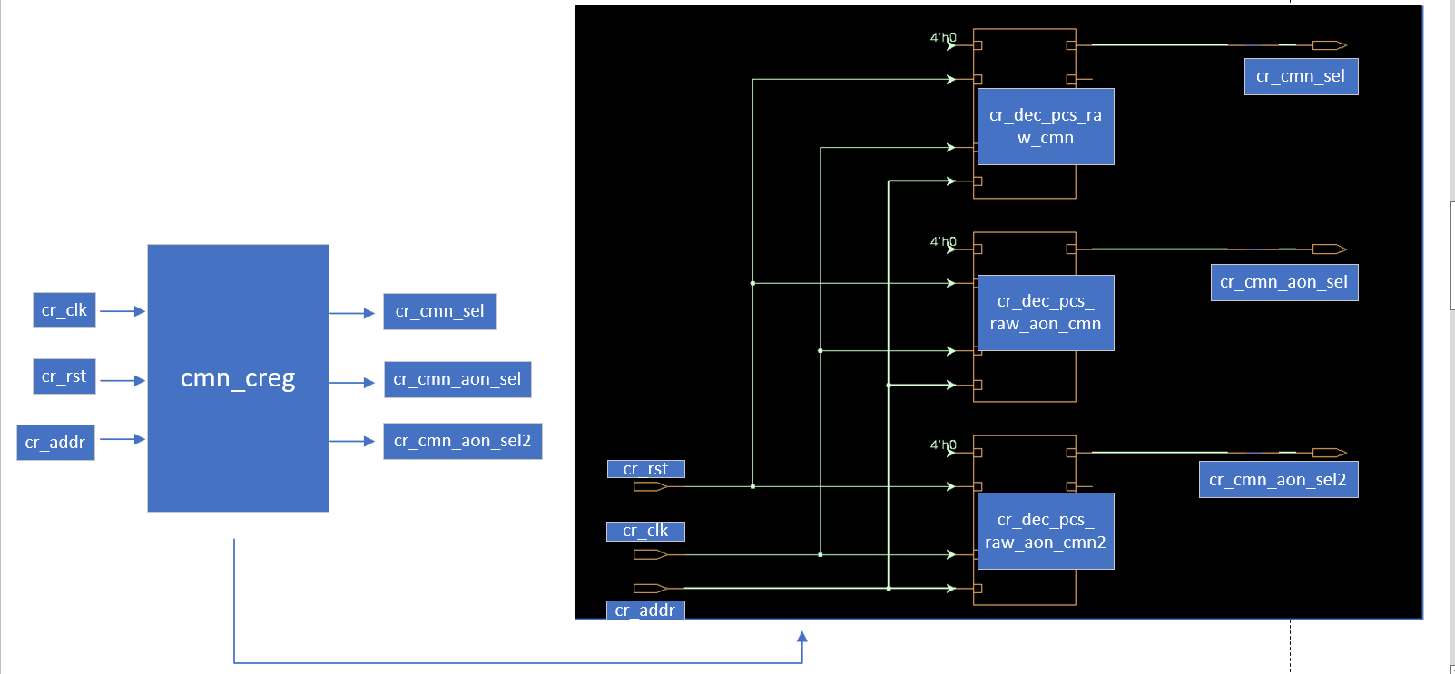

如上图所示，cmn_creg模块内部包含了cr_dec_pcs_raw_cmn模块、cr_dec_pcs_raw_aon_cmn模块和cr_dec_pcs_raw_aon_cmn2模块。cmn_creg模块的功能是用cr_addr产生pcs_raw_cmn内部寄存器片选和pcs_raw_aon_cmn寄存器片选。

cr_dec_pcs_raw_cmn 模块的功能是用cr_addr分别译码产生cr_cmn_sel[31:0] 片选信号，cr_dec_pcs_raw_aon_cmn 模块的功能是用cr_addr分别译码产生cr_cmn_aon_sel[31:0] 片选信号，cr_dec_pcs_raw_aon_cmn2 模块的功能是用cr_addr分别译码产生cr_cmn_aon_sel2[31:0]片选信号。

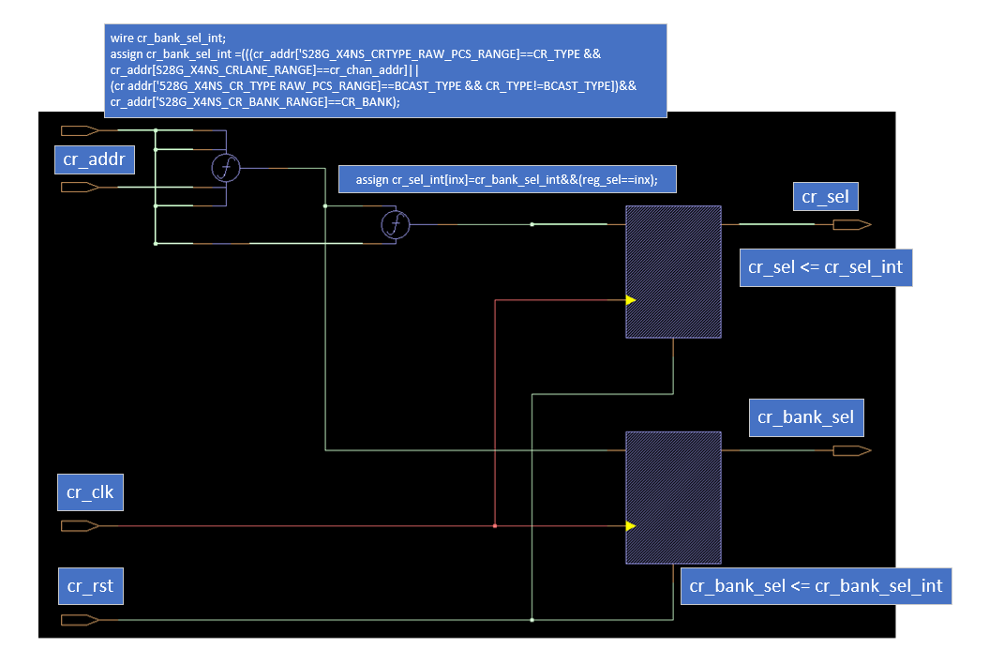

cr_dec_pcs_raw_cmn/cr_dec_pcs_raw_aon_cmn/cr_dec_pcs_raw_aon_cmn2内部结构相同，如上图所示，

cr_addr经译码函数f1/f2锁存后产生cr_sel和cr_bank_sel。其中cr_bank_sel_int为寄存器bank片选信号，reg_sel = cr_addr[4:0]模块内部寄存器编号，cr_sel_int是reg_sel独热码表示;cmn_creg模块例化cr_dec_pcs_raw_cmn/cr_dec_pcs_raw_aon_cmn/cr_dec_pcs_raw_aon_cmn2模块时cr_bank_sel没用，而是直接通过三条总线将cr_sel送到相应的模块。

### creg_ctl

|  |  |  |  |  |
| --- | --- | --- | --- | --- |
| **Signal name** | **I/O** | **From** | **To** | **Description/Function** |
| cr_para_sel_i | input | cmn |  | APB OR JTAG SELECT |
|  |  |  |  |  |
| cr_para_addr[15:0] | input | cmn |  | CR Parallel Interface |
| cr_para_wr_en | input |  |
| cr_para_wr_data[15:0] | input |  |
| cr_para_rd_en | input |  |
| cr_para_rd_data[15:0] | output |  | cmn |
| cr_para_ac | output |  |
|  |  |  |  |  |
| jtag_rst | input | jtag_ctl |  | JTAG Register interface |
| jtag_clk | input |  |
| jtag_clk_n | input |  |
| jtag_capture | input |  |
| jtag_shift | input |  |
| jtag_update | input |  |
| jtag_ser_in | input |  |
| jtag_crsel_sel | input |  |
| jtag_crsel_tdo | output |  | jtag_ctl |
|  |  |  |  |  |
| cr_addr[15:0] | output |  |  | Internal CREG interface |
| cr_wr_en | output |  |
| cr_wr_data[15:0] | output |  |
| cr_rd_en | output |  |
| cr_rd_data[15:0] | input |  |  |
| cr_ack | input |  |  |

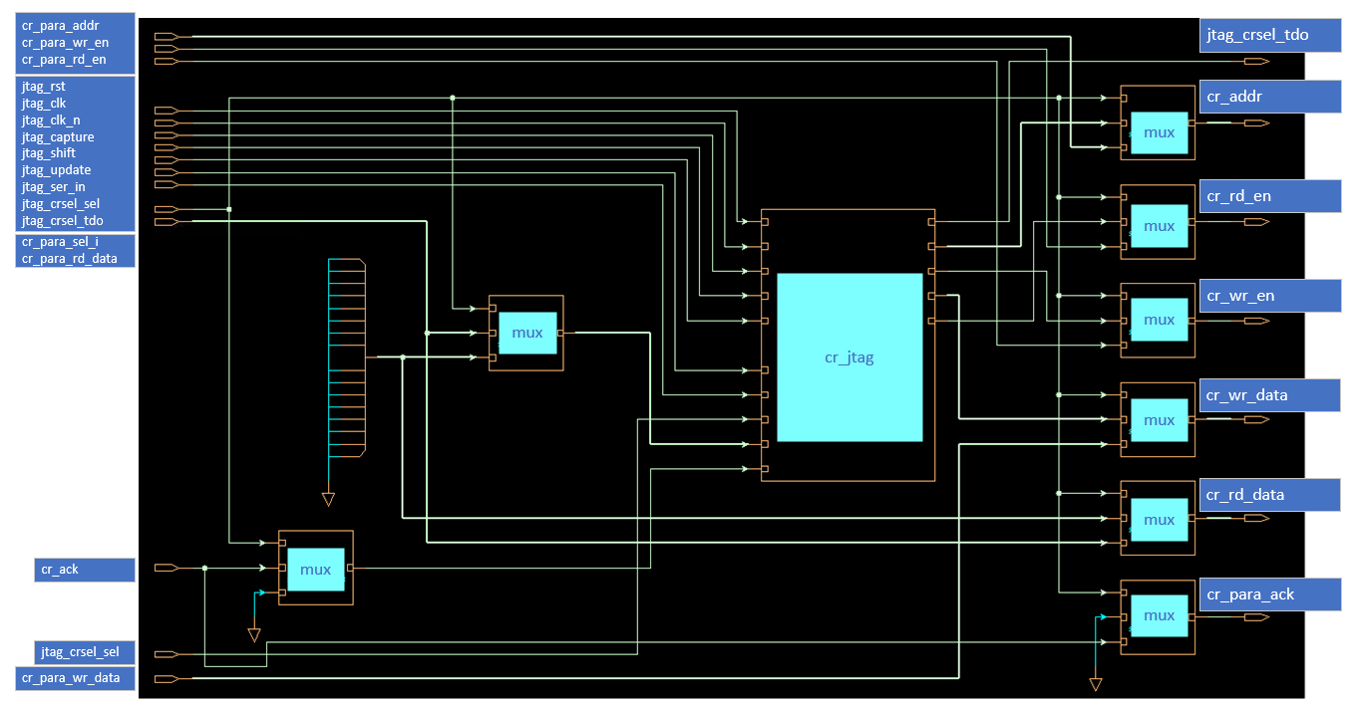

creg_ctl 模块内部包含了creg_jtag模块、cr_addr_mux模块、cr_wr_data_mux 模块、cr_wr_en_mux模块、cr_rd_en_mux模块、cr_para_rd_data_mux模块、cr_para_ack_mux模块、cr_jtag_rd_data_mux模块、cr_jtag_ack_mux模块。cmn_creg模块的功能是根据cr_para_sel_i (默认CR Parallel Interface)来切换 CR Parallel Interface和JTAG Register interfac产生Internal CREG interface。

creg_jtag模块的功能是将JTAG Register interface转换成cr interface。

cr_addr_mu模块是根据cr_para_sel_i选择完成cr_jtag_addr和cr_para_addr到cr_addr的切换。

cr_wr_data_mux模块是根据cr_para_sel_i选择完成cr_jtag_wr_data和cr_para_wr_data到cr_wr_data的切换。

cr_wr_en_mux模块是根据cr_para_sel_i选择完成cr_jtag_wr_en和cr_para_wr_en到cr_wr_en的切换。

cr_rd_en_mux模块是根据cr_para_sel_i选择完成cr_jtag_rd_en和cr_para_rd_en到cr_rd_en的切换。

cr_para_rd_data_mux模块是根据cr_para_sel_i选择完成0和cr_rd_data到cr_para_rd_data的切换。

cr_para_ack_mux模块是根据cr_para_sel_i选择完成0和cr_ack到cr_para_ack的切换。

cr_jtag_rd_data_mux模块是根据cr_para_sel_i选择完成0和cr_rd_data到cr_jtag_rd_data的切换。

cr_jtag_ack_mux模块是根据cr_para_sel_i选择完成0和cr_ack到cr_jtag_ack的切换。

### reg_arbt

|  |  |  |  |  |
| --- | --- | --- | --- | --- |
| **Signal name** | **I/O** | **From** | **To** | **Description/Function** |
| cr_clk | input |  |  | Clock and Reset |
| cr_rst | input |  |  |
|  |  |  |  |  |
| cr_req[15:0] | input |  |  | CR input interfaces （将16路cr interface 合并成256位总线输入，此处的地址就是reg map地址） |
| cr_addr[255:0] | input |  |  |
| cr_wr_data[255:0] | input |  |  |
| cr_wr_en[15:0] | input |  |  |
| cr_rd_en[15:0] | input |  |  |
| cr_op_xtnd[15:0] | input |  |  |
| cr_ack[15:0] | output |  |  |
| cr_rd data[15:0] | output |  |  |
|  |  |  |  |  |
| cr_arbt_addr[15:0] | output |  |  | CR output interface（切换后的cr_interface输出，此处的地址就是reg map地址） |
| cr_arbt_wr_data[15:0] | output |  |  |
| cr_arbt_wr_en | output |  |  |
| cr_arbtrd_en | output |  |  |
| cr_arbt rd_data[15:0] | input |  |  |

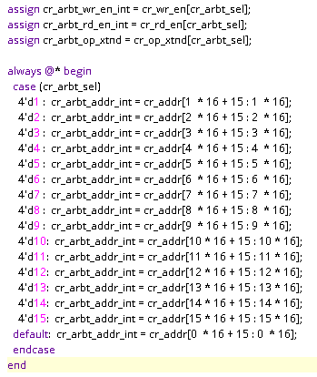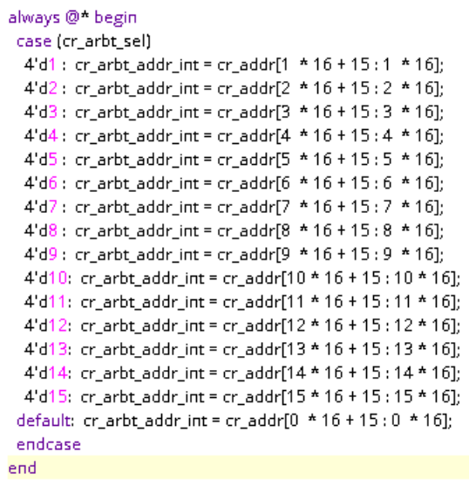

如上所示，reg_arbt模块的功能是根据cr_arbt_sel的值决定16路CR input interfaces的哪一路作为CR output interface，cr_arbt_sel由input wire [16-1:0] cr_req译码产生。本设计中用到4路，所以reg_arbt模块实现了4路cr interface 并行输入转换为4拍串行1路CR output interface输出的过程。

### mem

|  |  |  |  |  |
| --- | --- | --- | --- | --- |
| **Signal name** | **I/O** | **From** | **To** | **Description/Function** |
| cr_c1k | input |  |  | mem时钟 |
| cr_rst | input |  |  | mem复位 |
|  |  |  |  |  |
| cr_cmn[63:0]_b[7:0]_sel[31:0] | input | mem_creg[3:0] |  | mem中register片选 |
|  |  |  |  |  |
| cr_wr_en | input |  |  | mem中register写使能 |
| cr_wr_data[15:0] | input |  |  | mem中register写数据 |
| cr_rd_en | input |  |  | mem中register读使能 |
| cr_rd data[15:0] | output |  | Raw PCS lanes | mem中register读数据 |

mem用cmn[63:0]_b[7:0],b[7:0]表示8个bank，cmn[63:0]表示64个block，每个cmn block中包含32个16位的register，所以如果用4个bank，memory的大小为64（block）*32（register）*4（bank）=8192 registers (16bit)。mem的存储单元是寄存器接口和具体操作如下。

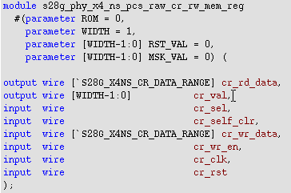

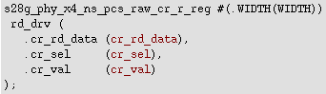

### mem_arbt

mem_arb模块接口与reg_arbt模块相同，mem_arb模块功能与reg_arbt模块相同。

区别在于mem_arb的输入输出为mem的地址和数据。

### mem_reg0

|  |  |  |  |  |
| --- | --- | --- | --- | --- |
| **Signal name** | **I/O** | **From** | **To** | **Description/Function** |
| cr_ck | input |  |  | mem时钟 |
| cr_rst | input |  |  | mem复位 |
| cr_addr | input | Raw PCS lanes |  | mem地址 |
|  |  |  |  |  |
| cr_cmn[15:0]_b[7:0]_sel | output |  | mem | mem中register片选 |

mem_reg模块的功能是通过对cr_addr[15:0](cr_addr外部连接cr_mem_addr)的译码产生cmn[15:0]_b[7:0][31:0]的片选信号。

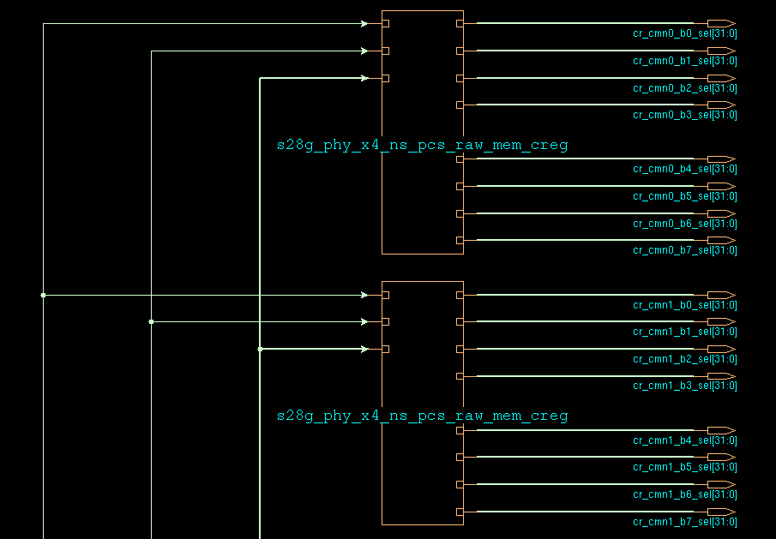

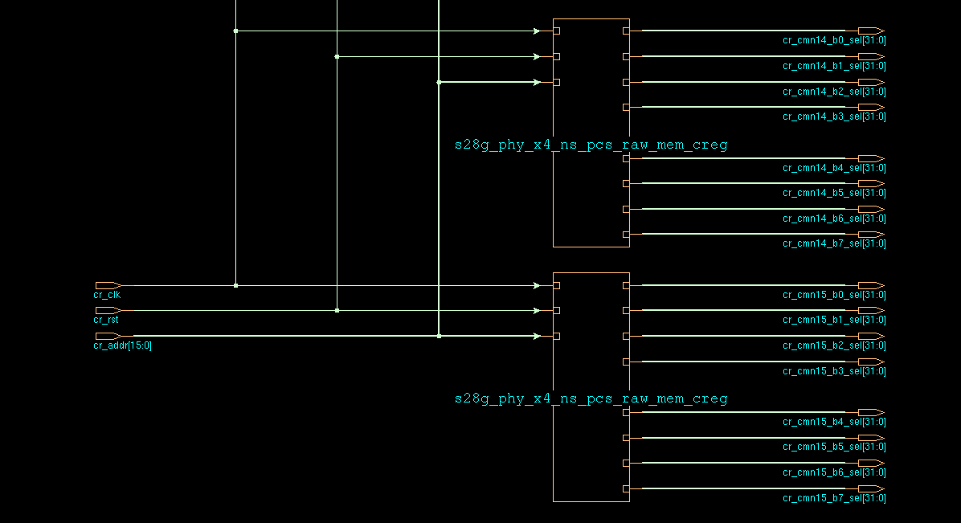

上图为cmn0_creg~cmn15_creg((block选择信号产生)),下图为cmnX_creg(bank选择信号产生)内部结构

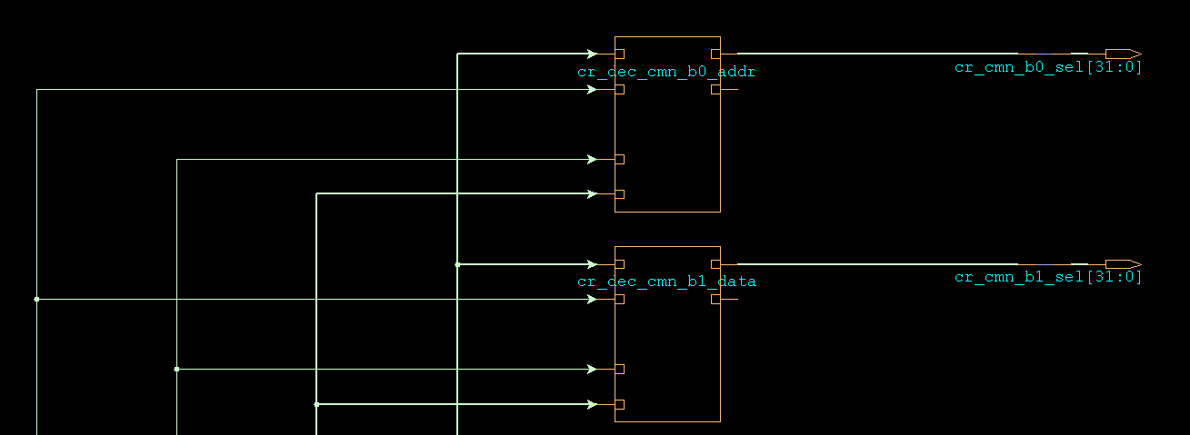

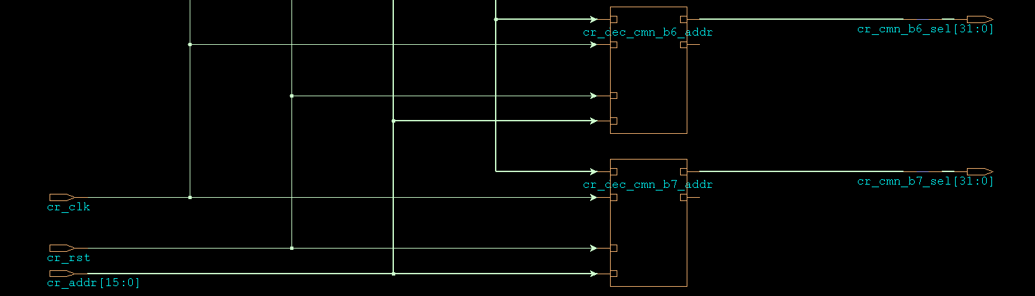

cr_dec_cmn_bx_addr模块的内部结构及实现方法与cr_dec_pcs_raw_cmn/cr_dec_pcs_raw_aon_cmn/cr_dec_pcs_raw_aon_cmn2内部结构及实现方法相同。

### mem_reg1

接口/内部结构及实现方法同上

产生cmn[31:16]_b[7:0]的片选信号

### mem_reg2

接口/内部结构及实现方法同上

产生cmn[47:32]_b[7:0]的片选信号

### mem_reg3

接口/内部结构及实现方法同上

产生cmn[63:48]_b[7:0]的片选信号

### reg_mapping

|  |  |  |  |  |
| --- | --- | --- | --- | --- |
| **Signal name** | **I/O** | **From** | **To** | **Description/Function** |
| i_cr_para_addr[15:0] | input |  |  | cr_para_add before mapping |
| i_cr para_rd data[15:0] | input |  |  | cr para_rd data before mapping |
| i_cr para wr_data[15:0] | input |  |  | cr para wr_data before mapping |
|  |  |  |  |  |
| o_cr para addr[15:0] | output |  |  | cr_para_add after mapping |
| o_cr para rd data[15:0] | output |  |  | cr para_rd data after mapping |
| o_cr para_wr_data[15:0] | output |  |  | cr para wr_data after mapping |

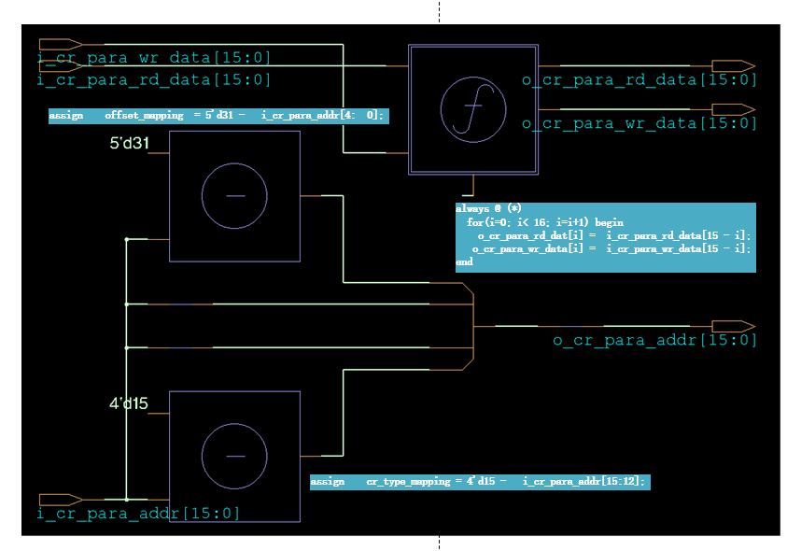

如上图所示，reg_mapping主要功能是完成对cr_para_add/cr_para_rd_data/cr_para_wr_data的映射操作。

## Hardware summarize

cr_ para_ addr[15:12]=4'b0101,PHY broadcasts to all PMA lanes.

cr_para_ addr[15:12]=4b0110, PHY broadcasts to all RAW PCS lanes.

cr_para_ addr[15:12]=4b0111, PHY broadcasts to all RAW PCS AON lanes.

The registers can be operated by firmware/jtag/apb.

Frimware operate register flow:1.Xlane.fsm get order and operate data through cr[7:0]_mem_bus ❶ ;2. Xlane.fsm complete register operate with reg_arbt through cr[7:0]_reg_bus❷;2. reg_arbt complete register operate with registers in every module through cr_bus❸ ;



# User guide

## 4.1 Configuration Requirements

## 4.3 Registers

# Special Note

# FPGA Verification

# Test Mode Strategy

# Simulation List